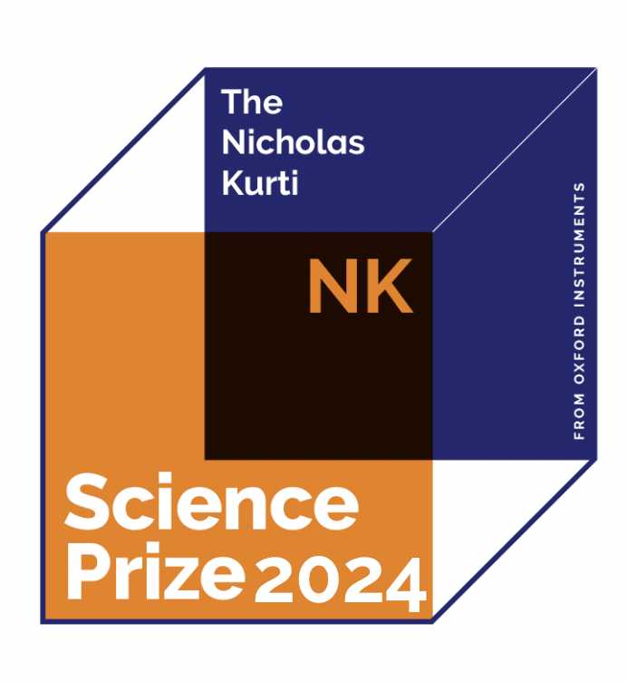
THE NICHOLAS KURTI SCIENCE OXFORD INSTRUMENTS PRESENTS THE SCIENCE PRIZE AWARDS
Supporting young scientists in Europe, conducting research employing low temperature and/or high magnetic fields
ABOUT NICHOLAS KURTI SCIENCE PRIZE
Oxford Instruments NanoScience, the world leader in the supply of superconducting magnets and low temperature cryogenic systems, has been proudly presenting the Nicholas Kurti Science Prize for Europe for 20 years. This prize aims to promote and recognise the novel work of young scientists working in low temperatures and/or high magnetic fields in Europe. We are aware that the critical stage between completing a PhD and gaining a permanent research position can be difficult for many young scientists. Through the NK Science Prize, we seek to help individuals who are already producing innovative work at this stage in their careers, both by financially contributing to their research and promoting it through this prestigious award.

RESEARCH AREA
Employing low temperatures and/or high magnetic fields.
ELIGIBILITY
Candidates should be producing work in research to a post doctoral level or equivalent (up to 7 years post PhD at the time of nomination). Candidates can be of any nationality but research must have been predominantly conducted in an European Institute.
ADJUDICATION
Adjudication will be by a committee of senior academics based throughout Europe. The criteria for selection of the prize winner covers the quality and originality of the research, the significance of results, impact of the work in setting a new direction for the research field and the degree of leadership demonstrated by the nominee in the work.
THE PRIZE
• 8,000 Euros cash prize
• Certificate and trophy
• Support to attend a conference in Europe
CANDIDATE’S NOMINATOR
The candidate may be nominated by a senior member of their department or institution. Nominations outside of this criteria are also permitted.
NUMBER OF NOMINATIONS
Each nominator may sponsor one applicant annually only.
NOMINATION METHOD
Nomination will take place using the application form available on our website, to be submitted in English.
SUBMISSION OF WORK
Nominations should include a summary of achievements and reason for nomination. This is to be accompanied by two references that the steering committee can contact. Work should be at least peer reviewed and preferably published.
Please submit your nominations to: nicholaskurtiprize@oxinst.com
TIMESCALES
Nominations will close on 5th January 2024.

