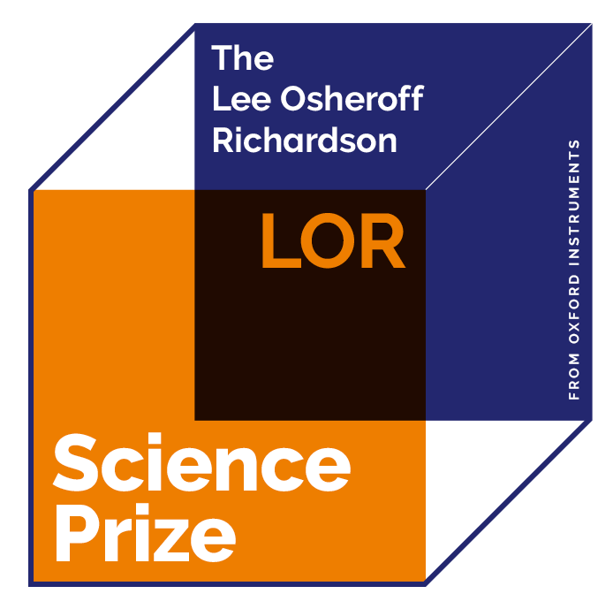
NOMINATION
FORM

CLOSING DATE FOR SUBMISSION OF NOMINATIONS FOR THE 2026 AWARD IS 30TH APRIL 2026

REQUIREMENTS

- PLEASE INCLUDE ALL OF THESE FILES IN ONE PDF DOCUMENT
- Two letters of support
- Candidate CV
- Up to three papers relevant to the application
  - Include a paragraph on each of the papers describing the importance and impact of that paper as well as the candidate’s contribution to the research reported in that paper
- Career summary of the candidate
- The candidates’ achievements, impact and originality, and the role of the research group in a manner which can be understood by researchers in other fields.
NOMINATOR (PLEASE USE BLOCK CAPITALS)
NAME: _____________________________________________________ |  | TITLE: _________________________________
ADDRESS: _______________________________________________________________________________________
TELEPHONE: _____________________________________________ |  | EMAIL: ________________________________
AFFILIATION: ____________________________________________________________________________________
CANDIDATE (PLEASE USE BLOCK CAPITALS)

FIRST NAME: _____________________________________________ |  | SURNAME: _____________________________
TITLE: ___________________________________________________ |  | PREFERRED PRONOUNS: _________________________
DATE OF BIRTH: __________________________________________ |  | PHD COMPLETION DATE:  (DD/MM/YY) ____________________________
CANDIDATES HOME ADDRESS: _____________________________________________________________________
TELEPHONE: _______________________ |  |  | EMAIL: _________________________
AFFILIATE’S ADDRESS: ____________________________________________________________________________
TELEPHONE: _______________________

CANDIDATE CV

To be included as a PDF attachment

THE RESEARCH

Proposed citation on the award for the Lee Osheroff Richardson
Science Prize (50 words or less):

THE CANDIDATE’S CAREER HISTORY
Career summary of candidate (including any prizes awarded):

THE CANDIDATE’S ACHIEVEMENTS

Please summarize achievements, their impact and originality, and the
role of the research group in a manner which can be understood by
researchers in other fields.

(Please continue on another sheet if needed, maximum 2 pages
in 12 pt font, single spaced with 1” margins)

THE MAIN PUBLICATIONS

List of main publications. Please give the title of the paper, authors, journal’s name,
volume, publication date and page. Please also attach files of up to three papers
relevant to the application and include a paragraph on each of the papers describing
the importance and impact of that paper as well as the candidate’s contribution to the
research reported in that paper (please continue on another sheet if needed).

REFEREES (PLEASE USE BLOCK CAPITALS)

Two letters of support from the below referees are to be attached as PDFs

1. NAME: _________________________________________________ | TELEPHONE: ___________________________
AFFILIATION: _____________________________________________ | EMAIL: _______________________________
2. NAME: _________________________________________________ | TELEPHONE: ___________________________
AFFILIATION: _____________________________________________ | EMAIL: _________________________________

NOTES

1. All references and papers to be in English.
2. The deadline for submission is on 30th April, 2026.
3. If you experience any difficulties, please email us at leeosheroffrichardsonprize.com.

